NMAP NETWORK SCANNING & ENUMERATION
Practical Report
Submitted By:
Name: Shravani Karpe
Class: T.E. CSE
Subject: Cybersecurity
Department: Computer Science & Engineering

1. Introduction
Nmap (Network Mapper) is an open-source network scanning and security auditing tool used to discover hosts, identify open ports, detect running services, determine operating systems, and gather information about networked systems.
Nmap is widely used by cybersecurity professionals and network administrators for network discovery, security assessment, troubleshooting, and reconnaissance.
In this practical, Nmap is used in an isolated VMware laboratory environment with Kali Linux as the scanning machine and Metasploitable 2 as the intentionally vulnerable target. Various Nmap scanning techniques are performed to understand how network hosts, ports, services, operating systems, and packet-filtering behavior can be identified.

2. Objective
The main objectives of this practical are:
- To understand the fundamentals of Nmap network scanning.
- To identify active hosts using Host Discovery.
- To identify open and filtered ports using Port Scanning.
- To detect running services and their versions using Service & Version Detection.
- To perform Operating System Detection.
- To use the Nmap Scripting Engine (NSE) for additional information gathering.
- To analyze possible firewall and packet-filtering behavior.
- To save and document Nmap scan results in report files.
- To understand basic network reconnaissance in an authorized and isolated laboratory environment.

3. Tools & Technologies Used
Kali Linux | Used as the scanning and security-testing platform
Nmap 7.99 | Used for network discovery, port scanning, service detection, OS detection and enumeration
Metasploitable 2 | Intentionally vulnerable virtual machine used as the authorized target
VMware | Used to create and manage the virtual laboratory environment

Software Environment
Scanner/Attacker Machine: Kali Linux
Target Machine: Metasploitable 2
Scanning Tool: Nmap 7.99
Virtualization Platform: VMware

5. Lab Environment / Network Configuration
The practical was performed in an isolated VMware virtual network, where Kali Linux was configured as the scanning machine and Metasploitable 2 was configured as the target machine.
Network Configuration
Machine | Role | IP Address
Kali Linux | Scanner | 192.168.184.128
Metasploitable 2 | Target | 192.168.184.130
Network Address: 192.168.184.0/24

Lab Architecture
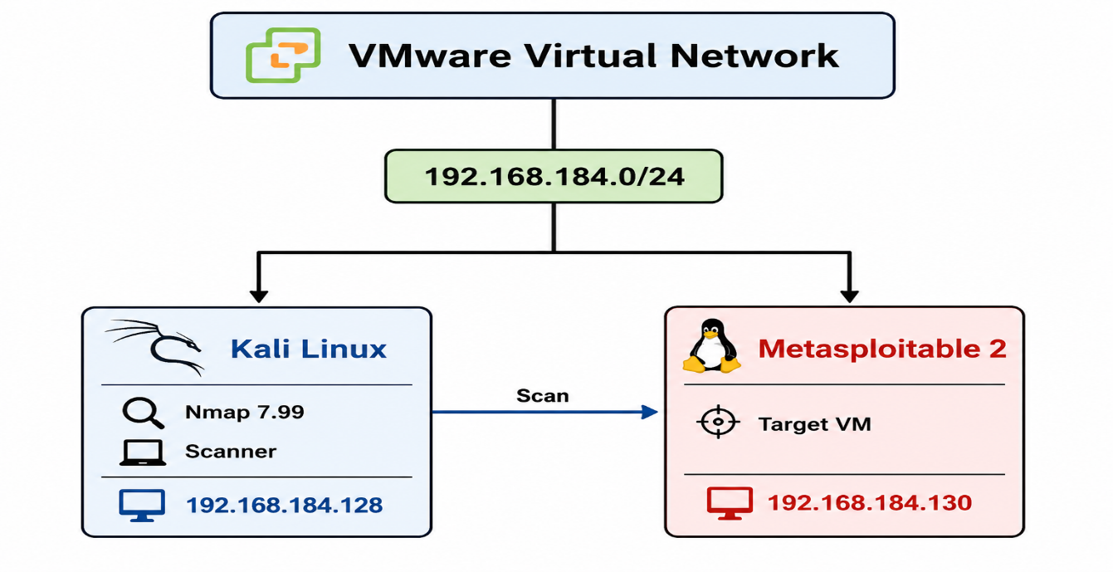

Network Configuration Screenshots
Figure 1: Kali Linux IP Configuration
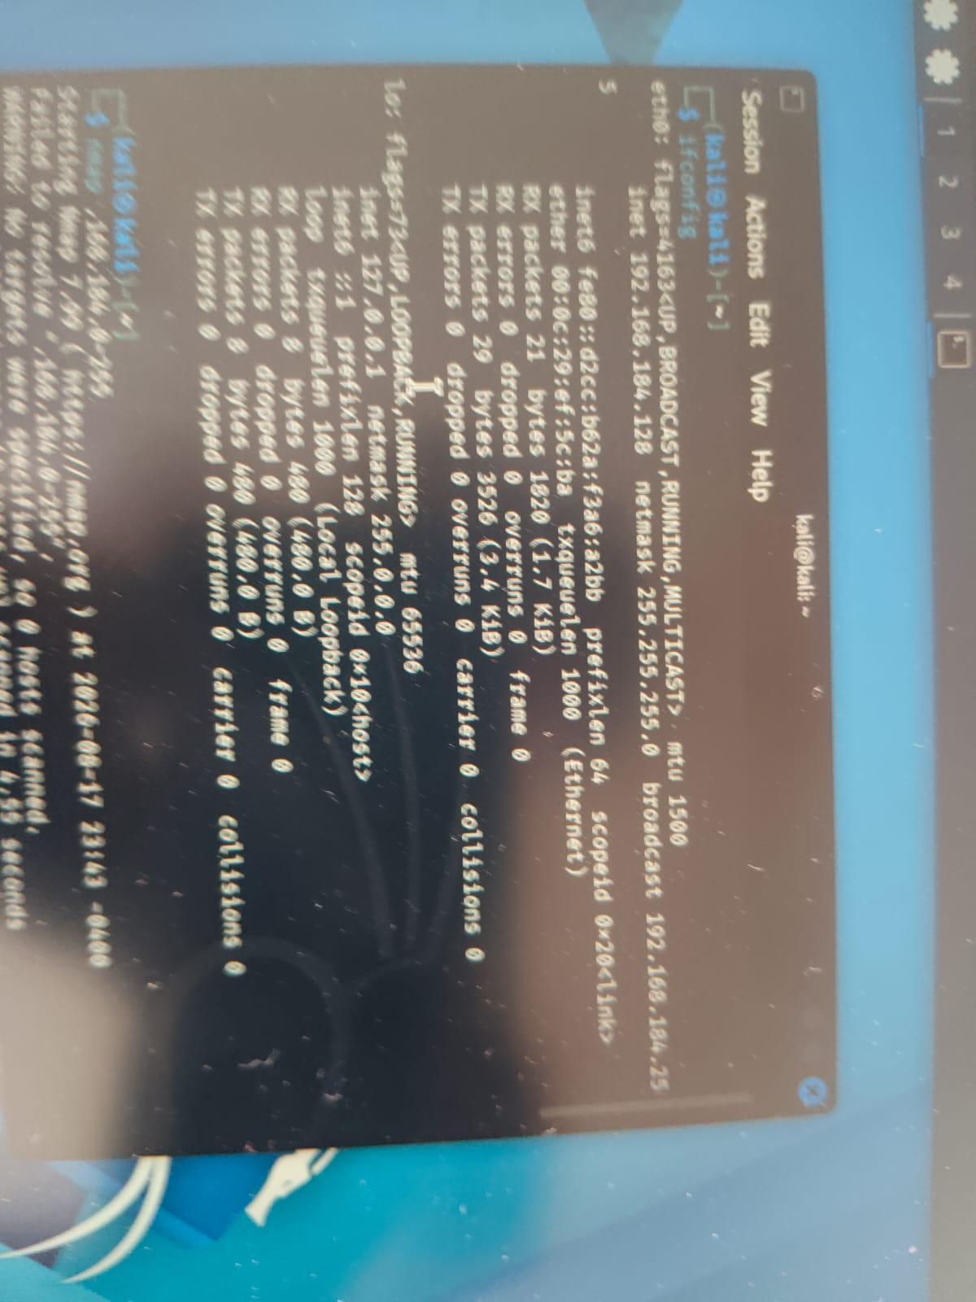
Figure 2: Metasploitable 2 IP Configuration

Observation
The Kali Linux system (192.168.184.128) and Metasploitable 2 system (192.168.184.130) are configured on the same 192.168.184.0/24 virtual network. This allows Nmap running on Kali Linux to communicate with and scan the authorized Metasploitable 2 target.

Kali Linux IP Configuration
The IP configuration of Kali Linux was checked using the ip addr command.
The Kali Linux system was assigned:
IP Address: 192.168.184.128
Network: 192.168.184.0/24
Interface: eth0
Command Used
ip addr
Result
The Kali Linux machine was successfully configured with IP address 192.168.184.128.

6. Network Connectivity Verification
Before performing Nmap scanning, connectivity between Kali Linux and Metasploitable 2 was verified using the ping command.
6.1 Ping Test
Command Used
ping 192.168.184.130
Explanation
The ping command sends ICMP Echo Request packets to the target system. If the target responds, it confirms that the target is reachable from the Kali Linux machine.
Output
The target responded successfully:
64 bytes from 192.168.184.130
Multiple successful replies were received from the target.
Screenshot
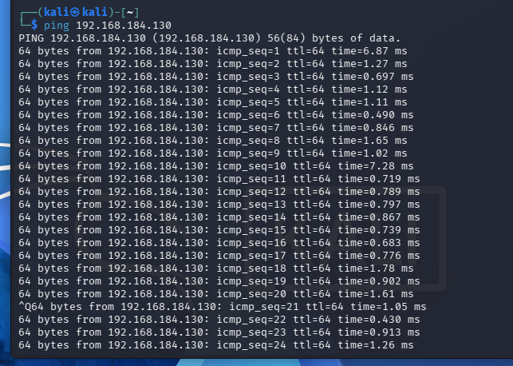
Caption:
Figure: Connectivity Verification using Ping
Result
The ping test confirmed that Kali Linux (192.168.184.128) could communicate with Metasploitable 2 (192.168.184.130).

7. Host Discovery
7.1 Host Discovery using Nmap
Host discovery is used to identify active systems within a network before performing detailed port scanning.
Command Used
nmap -sn 192.168.184.0-255
Explanation
The -sn option
The command checks the IP addresses in the 192.168.184.0 to 192.168.184.255 range and identifies hosts that are currently active.
Output
The scan identified 5 active hosts in the network.
The important target identified was:
Nmap scan report for 192.168.184.130
Host is up (0.00076s latency).
MAC Address: 00:0C:29:45:D2:2C (VMware)
Kali Linux was also detected:
Nmap scan report for 192.168.184.128
Host is up.
Screenshot
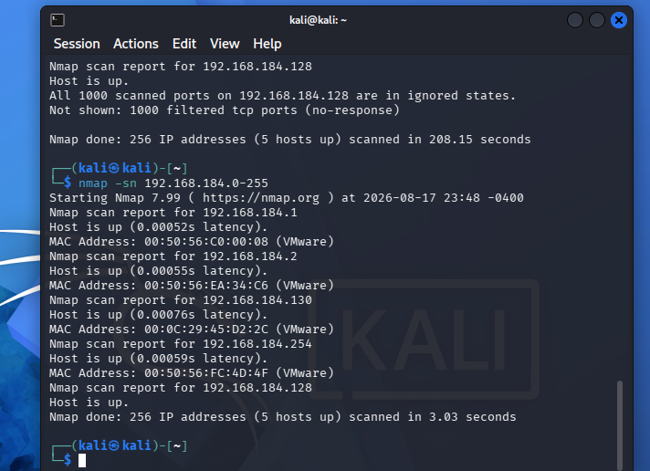
Caption:
Figure: Host Discovery using Nmap
Result
Nmap successfully identified active hosts on the VMware virtual network. The Metasploitable 2 target was identified at 192.168.184.130.

8. Basic Port Scanning
8.1 TCP Port Scan
After identifying the target host, a basic Nmap scan was performed against Metasploitable 2.
Command Used
nmap 192.168.184.130
Explains
A basic Nmap scan checks the most common TCP ports on the target and determines their current state.
The main states reported by Nmap include:
- Open — A service is listening on the port.
- Closed — The port is reachable but no service is listening.
- Filtered — Nmap cannot determine whether the port is open because packets are being filtered.
Output
The scan identified multiple open TCP ports.
PORT STATE SERVICE
21/tcp open ftp
22/tcp open ssh
23/tcp open telnet
25/tcp open smtp
53/tcp open domain
80/tcp open http
111/tcp open rpcbind
139/tcp open netbios-ssn
445/tcp open microsoft-ds
512/tcp open exec
513/tcp open login
514/tcp open shell
1099/tcp open rmiregistry
1524/tcp open ingreslock
2049/tcp open nfs
2121/tcp open ccproxy-ftp
3306/tcp open mysql
5432/tcp open postgresql
5900/tcp open vnc
6000/tcp open X11
6667/tcp open irc
Screenshot
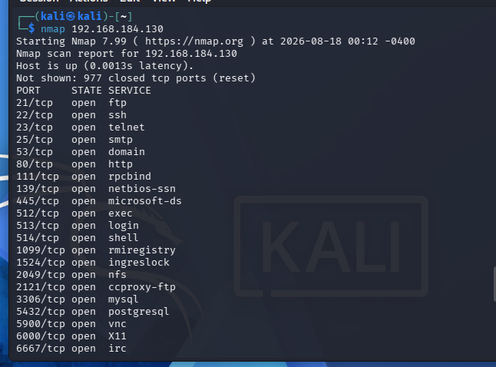
Caption:
Figure: Basic TCP Port Scan of Metasploitable 2
Result
The scan revealed several open services on the Metasploitable 2 system, indicating that the target exposes multiple network services.

9. Open Ports and Services
The basic scan identified the following open ports:
Port | Protocol | State | Service
21 | TCP | Open | FTP
22 | TCP | Open | SSH
23 | TCP | Open | Telnet
25 | TCP | Open | SMTP
53 | TCP | Open | Domain
80 | TCP | Open | HTTP
111 | TCP | Open | RPCBind
139 | TCP | Open | NetBIOS-SSN
445 | TCP | Open | Microsoft-DS
512 | TCP | Open | exec
513 | TCP | Open | login
514 | TCP | Open | shell
1099 | TCP | Open | RMI Registry
1524 | TCP | Open | Ingreslock
2049 | TCP | Open | NFS
2121 | TCP | Open | CCProxy-FTP
3306 | TCP | Open | MySQL
5432 | TCP | Open | PostgreSQL
5900 | TCP | Open | VNC
6000 | TCP | Open | X11
6667 | TCP | Open | IRC

10. TCP SYN Scan
10.1 SYN Stealth Scan
Command Used
nmap -sS 192.168.184.130
Explanation
The -sS option performs a TCP SYN scan. It sends SYN packets to the target ports and analyzes the responses to determine the port state.
This scan is commonly used for fast TCP port discovery.
Output
The scan identified the following open ports:
21/tcp open ftp
22/tcp open ssh
23/tcp open telnet
25/tcp open smtp
53/tcp open domain
80/tcp open http
111/tcp open rpcbind
139/tcp open netbios-ssn
445/tcp open microsoft-ds
512/tcp open exec
513/tcp open login
514/tcp open shell
1099/tcp open rmiregistry
1524/tcp open ingreslock
2049/tcp open nfs
2121/tcp open ccproxy-ftp
3306/tcp open mysql
5432/tcp open postgresql
5900/tcp open vnc
6000/tcp open X11
Screenshot
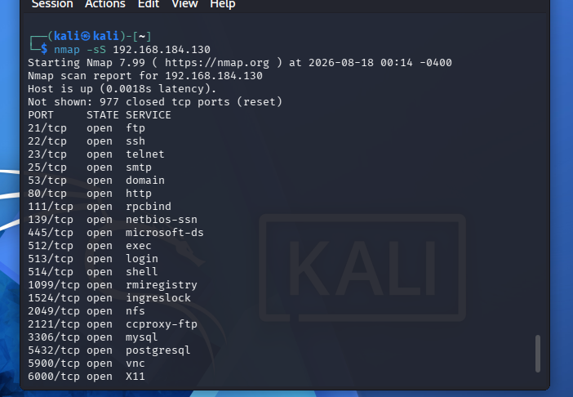
Caption:
Figure: TCP SYN Scan using Nmap
Result
The SYN scan successfully identified multiple open TCP ports on the Metasploitable 2 target.

11. TCP Connect Scan
11.1 TCP Connect Scan
Command Used
nmap -sT 192.168.184.130
Explanation
The -sT option performs a TCP Connect scan. Nmap uses the operating system's TCP connection mechanism to establish a connection with the target port.
Output
The scan identified multiple open services including:
21/tcp open ftp
22/tcp open ssh
23/tcp open telnet
25/tcp open smtp
53/tcp open domain
80/tcp open http
111/tcp open rpcbind
139/tcp open netbios-ssn
445/tcp open microsoft-ds
512/tcp open exec
513/tcp open login
514/tcp open shell
1099/tcp open rmiregistry
1524/tcp open ingreslock
2049/tcp open nfs
2121/tcp open ccproxy-ftp
3306/tcp open mysql
5432/tcp open postgresql
5900/tcp open vnc
6000/tcp open X11
Screenshot
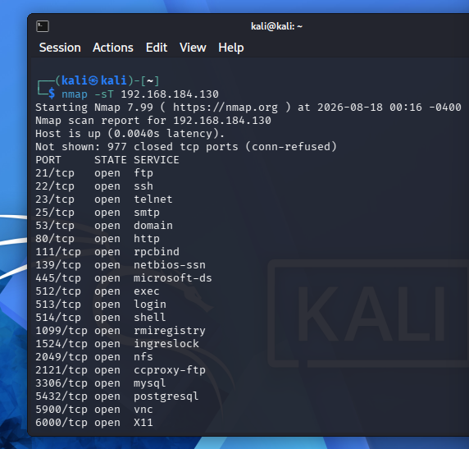
Caption:
Figure: TCP Connect Scan using Nmap
Result
The TCP Connect scan successfully detected open TCP services on the target.

12. UDP Scanning
12.1 UDP Port Scan
Command Used
nmap -sU -p 53 192.168.184.130
Explanation
The -sU option performs UDP scanning. UDP does not use the same connection establishment process as TCP, so Nmap uses UDP-specific responses to determine the state of a port.
The -p 53 option limits the scan to UDP port 53.
Output
The scan reported:
PORT STATE SERVICE
53/udp open domain
Screenshot
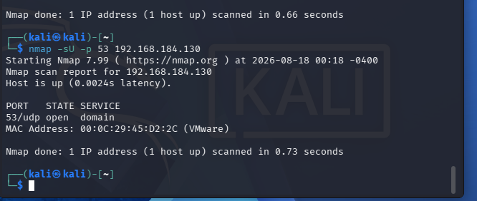
Caption:
Figure: UDP Port 53 Scanning
Result
UDP port 53 was identified as open and associated with the domain/DNS service.

13. Service & Version Detection
13.1 Service Detection
Command Used
nmap -sV 192.168.184.130
Explanation
The -sV option enables service and version detection.
Instead of only identifying the service name, Nmap attempts to determine the software and version running on each open port.
This information is useful for understanding the software exposed by the target system.
Output
The output should contain information in the following format:
PORT STATE SERVICE VERSION
21/tcp open ftp <detected version>
22/tcp open ssh <detected version>
23/tcp open telnet <detected version>
80/tcp open http <detected version>
3306/tcp open mysql <detected version>
📸 SCREENSHOT
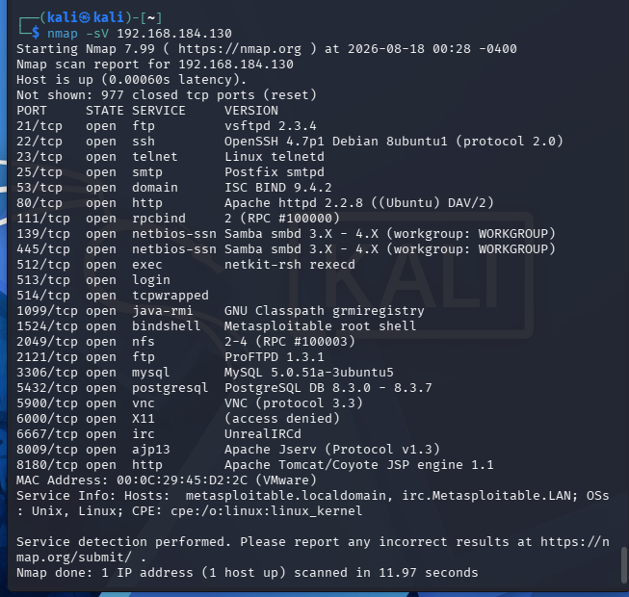
Caption:
Figure: Service and Version Detection using Nmap
Result
Service and version detection provides additional information about the software running on the target. The exact versions should be documented from the actual Nmap output.

14. Service Information Table
After performing -sV, prepare the following table using your actual detected versions:
Port | Service | Version / Information
21 | FTP | From -sV output
22 | SSH | From -sV output
23 | Telnet | From -sV output
25 | SMTP | From -sV output
53 | DNS | From -sV output
80 | HTTP | From -sV output
139 | NetBIOS | From -sV output
445 | Microsoft-DS | From -sV output
3306 | MySQL | From -sV output
5432 | PostgreSQL | From -sV output
5900 | VNC | From -sV output
Do not copy versions from another person's report.

15. Operating System Detection
15.1 OS Detection
Command Used
sudo nmap -O 192.168.184.130
Explanation
The -O option enables operating system detection.
Nmap analyzes characteristics of the target's network responses and compares them against its OS fingerprint database.
Output
Important information to record includes:
OS details:
Running:
OS CPE:
Network Distance:
📸 SCREENSHOT
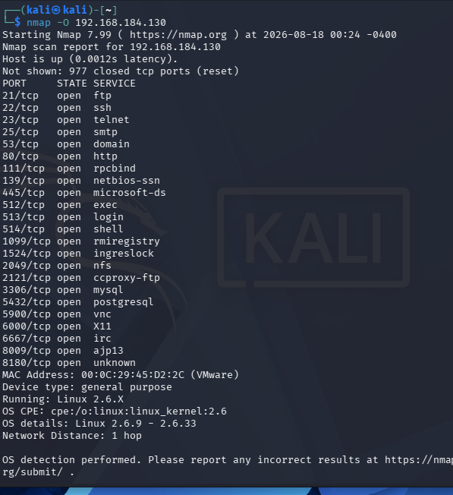
Caption:
Figure: Operating System Detection using Nmap
Result
The OS detection scan was used to identify the probable operating system of the Metasploitable 2 target.
Note: The exact OS identification should be written according to your actual Nmap output.

16. Firewall / Packet Filtering Analysis
16.1 ACK Scan
Command Used
nmap -sA 192.168.184.130
Explanation
The -sA option performs a TCP ACK scan.
ACK scanning is mainly used to determine whether ports are filtered or unfiltered by a firewall or packet-filtering mechanism. It does not directly identify whether a port is open.
Output
Your scan produced:
Nmap scan report for 192.168.184.130
Host is up.

All 1000 scanned ports on 192.168.184.130 are in ignored states.
Not shown: 1000 unfiltered tcp ports (reset)

MAC Address: 00:0C:29:45:D2:2C (VMware)
📸 SCREENSHOT
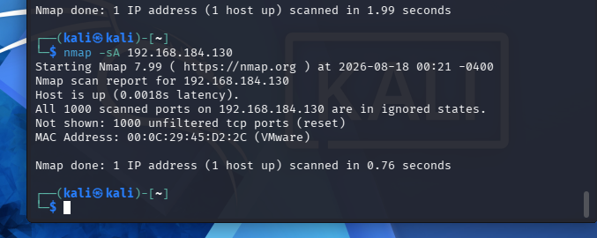
Caption:
Figure: Firewall and Packet Filtering Analysis using ACK Scan
Result
The ACK scan reported the scanned ports as unfiltered, meaning Nmap received responses indicating that the packets were not being blocked by a filtering mechanism.

17. NULL Scan
17.1 TCP NULL Scan
Command Used
nmap -sN 192.168.184.130
Explanation
The -sN option performs a TCP NULL scan.
A NULL scan sends TCP packets without setting the usual TCP flags. Nmap analyzes the response from the target to determine the port state.
Output
Your scan reported:
21/tcp open|filtered ftp
22/tcp open|filtered ssh
23/tcp open|filtered telnet
25/tcp open|filtered smtp
53/tcp open|filtered domain
80/tcp open|filtered http
111/tcp open|filtered rpcbind
139/tcp open|filtered netbios-ssn
445/tcp open|filtered microsoft-ds
512/tcp open|filtered exec
513/tcp open|filtered login
514/tcp open|filtered shell
1099/tcp open|filtered rmiregistry
1524/tcp open|filtered ingreslock
2049/tcp open|filtered nfs
2121/tcp open|filtered ccproxy-ftp
3306/tcp open|filtered mysql
5432/tcp open|filtered postgresql
5900/tcp open|filtered vnc
6000/tcp open|filtered X11
📸 SCREENSHOT
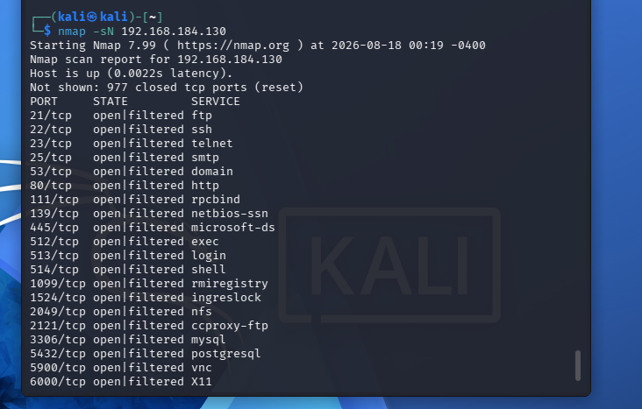
Caption:
Figure: TCP NULL Scan
Result
The NULL scan classified the ports as open|filtered, meaning Nmap could not definitively distinguish between open ports and ports filtered by a firewall.

18. FIN Scan
18.1 TCP FIN Scan
Command Used
nmap -sF 192.168.184.130
Explanation
The -sF option performs a TCP FIN scan.
The scan sends TCP packets with the FIN flag set and analyzes the response from the target to determine the state of ports.
Output
Your scan reported:
21/tcp open|filtered ftp
22/tcp open|filtered ssh
23/tcp open|filtered telnet
25/tcp open|filtered smtp
53/tcp open|filtered domain
80/tcp open|filtered http
111/tcp open|filtered rpcbind
139/tcp open|filtered netbios-ssn
445/tcp open|filtered microsoft-ds
512/tcp open|filtered exec
513/tcp open|filtered login
514/tcp open|filtered shell
1099/tcp open|filtered rmiregistry
1524/tcp open|filtered ingreslock
2049/tcp open|filtered nfs
2121/tcp open|filtered ccproxy-ftp
3306/tcp open|filtered mysql
5432/tcp open|filtered postgresql
5900/tcp open|filtered vnc
6000/tcp open|filtered X11
📸 SCREENSHOT
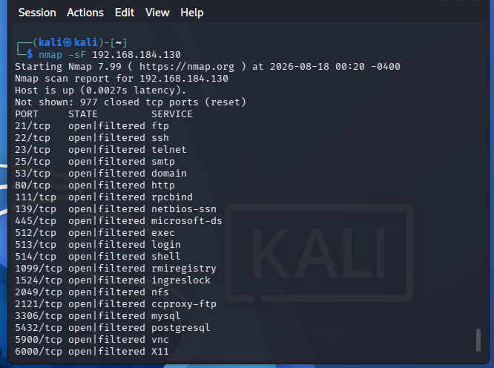
Figure: TCP FIN Scan
Result
The FIN scan returned open|filtered states for the listed ports, indicating that Nmap could not definitively distinguish between open and filtered ports from the responses received.

19. Port 80 Scanning Across the Network
19.1 HTTP Port Scan
Command Used
nmap -p 80 192.168.184.0-255
Explanation
The -p 80 option instructs Nmap to scan only TCP port 80.
The entire 192.168.184.0-255 address range was scanned to identify hosts with port 80 available.
Output
For the Metasploitable 2 target:
Nmap scan report for 192.168.184.130
Host is up.

PORT STATE SERVICE
80/tcp open http

MAC Address: 00:0C:29:45:D2:2C (VMware)
📸 SCREENSHOT
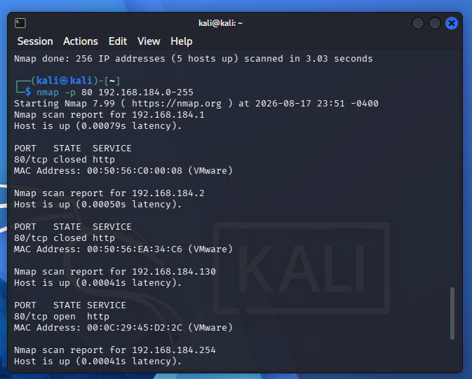
Caption:
Figure: HTTP Port 80 Scan Across the VMware Network
Result
TCP port 80 was found open on Metasploitable 2, indicating that an HTTP service is running on the target.

20. Network Host Discovery Summary
The host discovery scan was performed using:
nmap -sn 192.168.184.0-255
The scan identified five active hosts:
IP Address | Status | MAC / Vendor
192.168.184.1 | Up | VMware
192.168.184.2 | Up | VMware
192.168.184.130 | Up | VMware
192.168.184.254 | Up | VMware
192.168.184.128 | Up | Kali Linux
Result
The scan successfully discovered the active systems connected to the VMware virtual network.

21. Consolidated Open Ports
Based on the port scan performed on Metasploitable 2, the following services were identified:
Port | Protocol | Service
21 | TCP | FTP
22 | TCP | SSH
23 | TCP | Telnet
25 | TCP | SMTP
53 | TCP | DNS
80 | TCP | HTTP
111 | TCP | RPCBind
139 | TCP | NetBIOS-SSN
445 | TCP | Microsoft-DS
512 | TCP | exec
513 | TCP | login
514 | TCP | shell
1099 | TCP | RMI Registry
1524 | TCP | Ingreslock
2049 | TCP | NFS
2121 | TCP | CCProxy-FTP
3306 | TCP | MySQL
5432 | TCP | PostgreSQL
5900 | TCP | VNC
6000 | TCP | X11
6667 | TCP | IRC

22. Scan Summary
Scan Type | Command | Purpose | Result
Host Discovery | nmap -sn 192.168.184.0-255 | Find active hosts | 5 hosts identified
Ping | ping 192.168.184.130 | Verify connectivity | Target reachable
Basic Scan | nmap 192.168.184.130 | Find common open TCP ports | Multiple open ports
SYN Scan | nmap -sS 192.168.184.130 | TCP SYN scanning | Multiple open ports
Connect Scan | nmap -sT 192.168.184.130 | TCP connection scan | Multiple open ports
UDP Scan | nmap -sU -p 53 192.168.184.130 | Scan UDP port | 53/UDP open
Service Detection | nmap -sV 192.168.184.130 | Detect service/version | Add actual output
OS Detection | sudo nmap -O 192.168.184.130 | Detect OS | Add actual output
NSE Scan | nmap -sC 192.168.184.130 | Run default NSE scripts | Add actual output
ACK Scan | nmap -sA 192.168.184.130 | Analyze filtering | Ports unfiltered
NULL Scan | nmap -sN 192.168.184.130 | NULL flag scan | Open/filtered
FIN Scan | nmap -sF 192.168.184.130 | FIN flag scan | Open/filtered
Port 80 | nmap -p 80 192.168.184.0-255 | Find HTTP ports | 80/tcp open on target

23. Observations
The following observations were made during the practical:
- Kali Linux was configured with IP address 192.168.184.128.
- Metasploitable 2 was configured with IP address 192.168.184.130.
- Both systems were connected through the VMware virtual network 192.168.184.0/24.
- Ping successfully confirmed connectivity between the scanning and target systems.
- Nmap host discovery identified five active hosts on the virtual network.
- The basic port scan identified multiple open TCP ports on Metasploitable 2.
- FTP, SSH, Telnet, HTTP, MySQL, PostgreSQL, VNC and several other services were identified.
- TCP SYN and TCP Connect scans successfully identified open TCP services.
- UDP port 53 was identified as open.
- ACK scanning reported the scanned ports as unfiltered.
- NULL and FIN scans returned open filtered states.
- The practical demonstrated how different Nmap scan types produce different information about a target system.

24. Security Analysis
The large number of exposed services on the Metasploitable 2 system demonstrates why network enumeration is an important part of security assessment.
An attacker or security tester can use port and service information to understand the attack surface of a system. Service and version detection can provide additional information about the software running on open ports.
In a real production environment, unnecessary services should be disabled, firewall rules should be properly configured, software should be kept updated, and network exposure should be minimized.
This practical was performed in an authorized and isolated VMware laboratory environment.

25. Conclusion
This practical provided hands-on experience with Nmap for network scanning and enumeration.
Host discovery was first performed to identify active systems in the VMware virtual network. Connectivity between Kali Linux and Metasploitable 2 was then verified using the ping command.
Different Nmap scanning techniques were subsequently performed, including basic TCP scanning, TCP SYN scanning, TCP Connect scanning, UDP scanning, NULL scanning, FIN scanning and ACK scanning. The scans successfully identified multiple open services on the Metasploitable 2 target.
Service and version detection, OS detection and NSE scripting can further extend the information gathered during network enumeration. The practical also demonstrated how Nmap can be used to analyze packet filtering and save scan results for reporting.
Overall, the practical helped develop a better understanding of network reconnaissance, port scanning, service enumeration and basic security assessment using Nmap in an authorized laboratory environment.

